**Rose mousse**

Kelaat M'Gouna is an important economic and social center in the region, whose population doubles during the rose festival.

Indeed, this festival is very popular with foreign tourists, as well as Moroccans from other cities in the Kingdom who come to discover perfumes and cosmetics made from the distillation process.

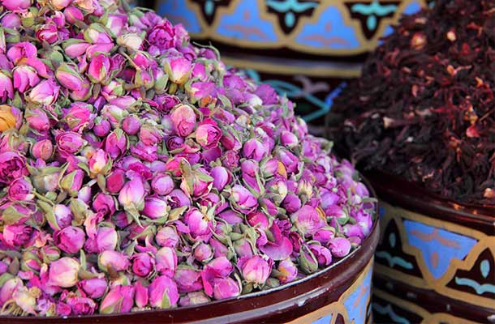

At the same time know that rose water is highly appreciated in traditional daily life. cuisine and in oriental pastries. It usually starts in the second week of May and lasts for 3 days.

On this occasion, people dress up in their best clothes, sprinkle rose water and flower petals on each other, sing and dance in the streets with traditional dances such as the sword dance or the bee dance.

A young unmarried woman is elected Miss Rose for the day and will travel around in her float decorated with flowers, accompanied by music and songs throughout parade.

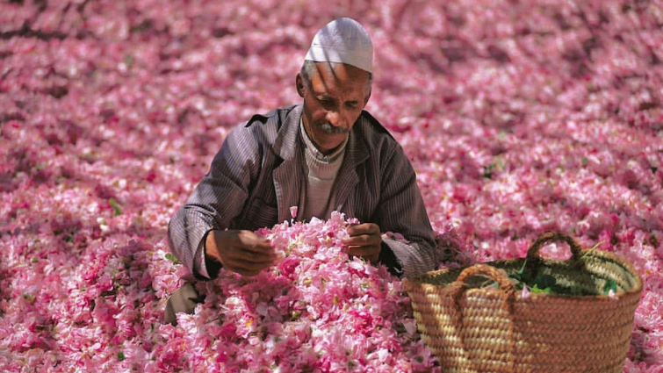

Rose water, Kelaat M'Gouna's treasure

Oral legend has it that Rosa Damascena was brought back in the 10th century when a group of Berber pilgrims returning from Mecca, were impressed by the flower's beauty and fragrance. They brought back some roses and replanted them in the Kelaat M'Gouna area.

Some of the seeds that fell on the way germinated and then bloomed to produce beautiful roses that adorned and made famous this part of the High Atlas, which became the valley of the roses.

It was in April and May, from dawn, the women were busy picking precious flower petals. Nearly 1,000 tons will be harvested for distillation at two plants in Kelaat M'Gouna and Souk-el-Khemis.

The copper stills process no less than 300 kg of flower petals soaked in 700 liters of boiling water. The steam dissolves the essence-filled aromatic oils, passes through cooling tubes and directs the liquid into a tank, at the bottom of which the rose water is stored while the essence floats.

It will be extracted and packaged as essential oil. The rose is prized for its fragrance and aesthetic qualities, and is part of the traditional pharmacopoeia.